A
Project Report
On
“Remote Operating System (OS) Installation “

Submitted By

Under the guidance of
(Guide)

Introduction

Chapter 1
Introduction

1.1 Project Definition and Relevant Theory:
What if you want to install OS on a number of clients at a time or if you want to install different kind of OS on a number of clients at a time, yes it will not be possible to do this simultaneously on number of clients at a time. If it is possible it will be definitely time consuming as well as expensive.
The concept of remote OS installation is already implemented by Microsoft. This remote OS installation is for windows 2000 Server OS only. The Remote Installation Services (RIS), an optional component of the Windows 2000 Server operating system, works with other Windows 2000 technologies to implement the Remote OS Installation feature, providing companies with the ability to remotely install a copy of the Windows 2000 Professional operating system on supported computers throughout the enterprise. Microsoft allows us to install only win 2000 on client machine. This is major drawback of remote OS installation. Important thing about our project is that administrator allows to install desired operating system i.e. Win Xp or any Windows version on client machine.

1.1.1 Why Remote OS Installation?
One of the most challenging and costly functions performed by IT staff today is the deployment of an operating system (OS) to new or existing client computers. Currently, organizations spend a great deal of time and expense planning, designing, and rolling out the latest version of the operating system throughout the organization. Often this process is done manually, requiring a help desk professional to physically visit each computer.

1.1.2 System Overview:

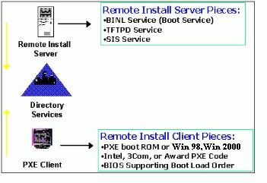
Fig 1.1: Remote OS Installation Server and Client Requirement

- Remote Installation Service(RIS)
RIS provides software services that allow an administrator to set up new clients remotely, without having to visit each client.

- Active Directory
RIS relies on the Active Directory directory service for many things. RlS uses Active Directory for locating existing client machines as well as existing RIS servers.

- Client
Every machine in a LAN should have Win98 as the basic Operating System, the administrator can check the client Configuration and can install another Operating System.

1.1.3 Working of Proposed System:
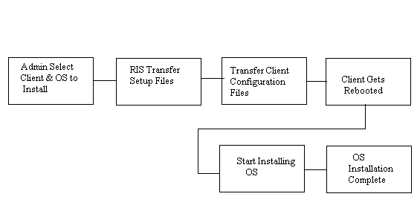
Fig 1.2: Working of Remote OS Installation

First Administrator will select Client & the OS to be installed. Then RIS will transfer setup file of desired OS. This initiates a Transfer program i.e. the setup is available on the Server Root Directory and the Image of it is transferred to the selected client machine. The administrator before transfer of Setup first creates a Configuration file which contains information regarding the OS Configuration on the Client machine.
Then transfer of client configuration files will be takes place on client machine. Then Client will get rebooted. After that actual installation of OS will be started. In this way OS installation will be takes place remotely.

1.2 Scope :
1) This software will work as a communication medium for the employees of
an organization connected in a LAN. The tool is designed to work on an
Intranet.
2) The one who is going to use the software must be an employee (Administrator)
of the organization. He will be validated for his name and password as to use
the Software.
3) Client side machine should have Win98 or Win 2000 as the basic Operating
System the administrator can check the client Configuration and can
install another Operating System which will enable smooth functioning and
better efficiency on the client side based on objectives of the organization.

1.3 Objectives:
- Design of GUI of Server side machine
- View Client configuration
- Design of Setup transfer module
- Design of Remote Installation Process
- Providing security by Admin authentication and login
- Monitor client side installation.

Requirement Analysis and System Design

Chapter 2
Requirement Analysis and System Design

Requirement analysis is the software-engineering task that bridges the gap between the software allocation and the software design. It is the process of discovery, refinement, modeling and specification. Requirements establish an understanding of the user’s needs, and also provide the final yardstick against which implementation success is measured. In requirement analysis phase we deal with the requirements of company related to project features, platform used for development, language etc.

2.1 General Aspect
2.1.1 Initiating the Process
The most commonly used analysis technique to bridge communication gap between customer and the developer and to get the communication process started. The idea of project Remote OS Installation came from the demand of large industries for using this system as a remote installation all the clients should satisfy minimum requirement.

2.1.2 Information Domain
The information domain consists of three different views of the data and control and each is processed by a computer program.
- Information content and relationships for this we collected specific need about the requirements of the customer ,jotting down the field names and functionalities of the system
- Information flow: It represents the manner in which data and control each move through the system .This is required for the analysis of the flow of control in the system giving the idea about the different modules and parts of the software system.
- Information structure: It represents the internal organization of various data and control items. It provides us the information about the data structure, files and tables to be used with functionality in the system.
2.2 Requirements Specifications:

2.2.1 Normal Requirements:
N1. Install Operating System on the Remote client system.
N2. Graphical user interface provides user for easy interaction with application
software.

2.2.2 Expected Requirements:
Exp1. Detecting Active Nodes in the network.
Exp2. Authorized user can only use RIS system.
Exp3. User can install Remote OS on number of clients at one time

2.2.3 Exciting Requirements:
Ex1. User can view client side process and can kill any running process.
Ex2. User is able to view client memory, processor and partition configuration

2.3 Validation of Requirements:
A validation criterion is probably the most important and ironically, the most often neglected section of s/w requirement specification. How do we recognize a successful implementation? What classes of tests must be conducted to validate the functions, performance and constraints? We neglect this section because completing its demands through understanding of s/w requirements, something that we often do not have at this stage. Yet, the specification of validation criteria acts as an implicit review of all the requirements. It is essential that time and attention to be given to this section.

N1: Completion of Remote OS Installation on remote client can be visualized
through a progress bar on a server screen.

Exp1: Active node in the network can be identified using polling method.
Exp2: By providing login name and password we can validate authorized user.

2.4 Software Requirements:
1) Operating System - Win98/Win 2000 /Win XP/Linux
2) VB 6.0
2.5 Hardware Requirements
1) P4 2.4 and Above Processor
2) 256 MB of RAM
3) 10/100 MBPS Ethernet Card (100 preferable for good data rate)

2.6 Process Model
To solve actual problems for an industry setting, a software engineer or a team of engineers must incorporate a development strategy that encompasses the process, methods, and tools, layers. A process model for software engineering based on the nature of the project and applications, the methods and tools to be used, and the controls and deliverables that are required The software process model used by us is the Linear Sequential Model.

Communication
Project initiation
Requirement gathering

Planning
Estimating
Scheduling
Tracking
Modeling
Analysis
Design
Construction
Coding
Testing

Deployment
Delivery
Support
Feedback
Fig 2.1: Linear sequential model
2.7 Breakdown Structure (Modules):

Server & Client
Connection
Graphical user interface
Transfer
Setup
Setup Monitoring
Remote OS Installation
R IS
Setup
Manager
Active Directory
Fig 2.2: Remote OS Installation: Breakdown structure (modules)

2.7.1 Server and Client Connection
In this module we are going to design a Server Architecture and a Client which will be communicating using UDP protocol. Here we will establish server and client connection. This module will help us to transfer the set up files.
2.7.2 Graphical User Interface (GUI)
This module is provides user for easy interaction with system. Various operation performed by user (Admin) will be done very easy and effectively. Here we are providing graphical way to user.
2.7.3 Setup Manager
This module consist of 2-submodule. It manages the setup files to be transferred on each client machine and before transmitting setup files active directory gives list of active node in the network.

2.7.3.1 Remote Installation Services (RIS)
Remote Installation Services (RIS) is a component that ships as part of the Server operating system. This will help to initiating the installation process on client. This module consists of three sub-modules which will discuss in next chapter.

2.7.3.2 Active Directory
RIS relies on the Active Directory directory service for many things.RlS uses Active Directory for locating existing client machines as well as existing RIS servers. This also keeps the record of no images stores in RIS server. According to rights user can install OS on particular client.

2.7.4 Transfer Setup
This module consist important task which is to initiates a Transfer program i.e. the setup is available on the Server Root Directory and the Image of it is transferred to the selected client machine.

2.7.5 Setup Monitoring
As the transfer program is in progress the admin can view the status of the Setup on the client machine. It also includes waiting for acknowledgements from client.

2.8 Project Estimation:-
2.8.1 Estimation in KLOC:-
Table 2.1: Estimation in KLOC
Function | Estimated KLOC
Server & Client Connection | 1.00
Graphical User Interface(GUI) | 0.25
Setup Manager | 0.70
RIS | 1.00
Transfer Setup | 0.50
Setup Monitoring | 0.25
Total: | 3.70

2.8.2 Efforts in Person in Months:-
E= 3.2 * (KLOC) ^ 1.05
E=3.2*3.7^1.05
E=12.64 months
2.8.3 Development Time in Months:-
D=E/N, where E=Effort in person month, N=number of persons required.
D=12.64 / 4
D=3.16 months
2.8.4 No of Persons Required:-
4 persons are required to complete the project with given time span successfully.

System Analysis and Risk Management

Chapter 3

System Analysis and Risk Management

Analysis part represents the customer requirements e.g. Analysis step includes stepwise specifications of the program or process to represent requirements, analysis includes three domains.
- Information domain
- Functional domain
- Behavioral domain

3.1 Project Scheduling and Tracking

3.1.1 Project Work Breakdown Structure (Analysis)

RIS

T1: Communication
T2: Planning
T3: Modeling
T11: Project
Initiation
T12: Requirement Gathering
T21:
Estimation
T22: Project
Scheduling
and tracking
T31: Analysis
T32: Design

Fig 3.1: Break down structure (a)
T1: Communication:
Software development process starts with the communication between customer and developer. According to need of project, we gathered the requirements related to project.

T2: Planning:
It includes complete estimation and scheduling (complete timeline chart for project development shown in 3.1.3) and tracking (shown in 3.3).

T3: Modeling:
It includes detailed requirement analysis and project design as shown in chapter 2.

3.1.2 Project Work Breakdown Structure (Implementation)

Remote OS Installation

T2: Delivery
T11: Server and Client connection
T12: Graphical user interface
T14: Transfer
Setup
T13: Setup
Manager

T1: Construction
T131: RIS
T15: Setup Monitoring

T17: Testing &
Debugging
T16: Integrating S/W & H/W modules
T132: Active
Directory
T1312: TFTP

n
T1311: BINL

T1313: SIS

Fig 3.1: Break down structure (b)

T1: Construction
It includes coding and testing steps. Design details are implemented using advanced java language.
T11: Server and Client Connection
We are going to design a Server Architecture and a Client which will be communicating using UDP protocol. On the entire client Machine we should have atleast Win 98 or Win 2000 Installed. All the Client are connected to the Server through LAN, Routers etc. When the client is booted it gets connect to the server. The client finds the server on the LAN. The administrator on the Server machine can view the connected client machine and can also view the details of the client. Details such as free memory, free hard disk space, type of OS installed, hardware configuration etc.
T12: Graphical user interface
This module is provides user for easy interaction with system. All the file related operation so that user want to do is provided in the form of graphical way.
T13: Setup Manager
Setup manager consist of two major part first is RIS and second is active directory.
T131: RIS
RIS that is remote installation services is the main part of the remote os installation and by using this it is possible to carry the OS images to client side.
T132: Active Directory
This module is come under main module setup manager. Active directory work as client list directory. It will keep the track of number of node attaches to RIS server as well as number of RIS server working in the network. Once the user logs on, RIS checks the Active Directory for a corresponding user account, verifying the password. RIS then checks the RIS specific Group Policy settings to find out which installation options the user should have access to

T14: Transfer Setup
First Administrator selects the client and the OS to be installed on the Client machine. This initiates a Transfer program i.e. the setup is available on the Server Root Directory and the Image of it is transferred to the selected client machine. In this way this module gives us initiation of OS installation.

T15: Setup Monitoring
This module will keep the track of whole installation process. It will give current status of client machine. It will inform about any error which may be come during installation.

T16: Integrating S/W & H/W
In this phase we will collect all the s/w modules & integrate them with h/w devices.

T17: Testing and debugging
Testing is carried out to check whether flow of coding is correct, to check out the errors of required module.

T2: Delivery
Final delivery of project will be given along with the necessary documentation.
- Each task is assigned to one or more team members, where
D1: Shinde B. B.
D2: Kale A.A.
D3: Ghatkar N.L.
D4: Gaikwad S.S.

3.1.3 Preparing Project Table:
Table 3.1: Project scheduling table (Analysis and Design)
Task | Plan start | Actual start | Plan complete | Actual complete | Person assign
T11 | 1 July | 2 July | 15 July | 31 July | D1,D2,D3,D4
T12 | 1 Aug | 1Aug | 7 Aug | 12 Aug | D1,D4
T21 | 13 Aug | 14 Aug | 21 Aug | 21 Aug | D3
T22 | 22 Aug | 22 Aug | 4 Sept | 5 Sept | D1,D2,D3
T31 | 5 Sept | 5 Sept | 13 Sept | 20 Sept | D2,D3
T32 | 20 Sept | 22 Sept | 2 Oct | 8 Oct | D2,D4

Table 3.2: Project scheduling table (Implementation)
Task | Plan start | Actual start | Plan complete | Actual complete | Person assigned
T11 | 20Dec | 21 Jan | 15 Jan | 30 Jan | D1,D2
T12 | 20 Dec | 1 Feb | 27 Dec | 7 Feb | D3,D4
T13 | 28 Dec | 20 Feb | 15 Jan | 12 March | D3,D4
T131 | 16 Jan | 5 March | 31 Jan | 12 March | D1,D3
T1311 | 16 Jan | 5 March | 25 Jan | 7 March | D2
T1312 | 16 Jan | 8 March | 25 Jan | 10 March | D4
T1313 | 27 Jan | 10 March | 31 Jan | 12 March | D2,D4
T132 | 1 Feb | 20 Feb | 21 Feb | 28 Feb | D1,D2
T14 | 1 Feb | 12 March | 15 Feb | 17 March | D3,D4
T15 | 16 Feb | 19 March | 21 Feb | 27 March | D3,D4
T16 | 22 Feb | 26 March | 28 Feb | 2 April | D1,D2
T17 | 1 March | 3 April | 10 March | 10 April | D1,D2,D3,  D4
T2 | 11 March |  | - | 17 April | D1,D2,D3

3.1.4 Time Line Chart:

3/07  17/07  T11  T12  T21  T22  T31  T32 | 31/07 | 14/08 | 28/08 | 11/09 | 25/09 | 02/10  M1 | 16/10  M2

Fig 3.2(a): Time line chart (analysis and design)
M1: Requirement gathering and analysis must be achieve.
M2: All necessary design must be complete.

20/12  03/01  T11  T12  T13  T131  T1312  T2  T17  T16  T15  T14  T1312  T1313 | 28/01 | 04/02  M1 | 18/02 | 04/03 | 14/03 | 18/03  14/03  M2 | 10/04  M3
T1311
M1: Server and client connection must be done effectivly.
M2: RIS and Active directory must be designed efficiently.
M3: All the s/w and h/w modules should be easily integrated.
Fig 3.2(b): Time line chart (Implementation)

3.2 Analysis Model:
Analysis includes three domains
- Behavior modeling
- Functional modeling
- Architectural modeling

UML Diagrams
Design modeling uses a combination of text and diagrammatic forms to depict the requirements for data, function and behavior in a way that is relatively easy to understand and more important, straightforward to review for correctness, completeness and consistency.
A diagram is the graphical presentation of a set of elements most often rendered as a connected graph of vertices (things) and arcs (relationship). These diagrams are drawn to visualize a system from different perspectives so a diagram into a system.

3.2.1 Behavior Modeling
3.2.1 1 Use Case Diagram:
It shows a set of use cases and actors (a special kind of class and their relationships). Use case diagrams address the static use case view of system. These diagrams are especially important in organizing and modeling the behavior of a system.
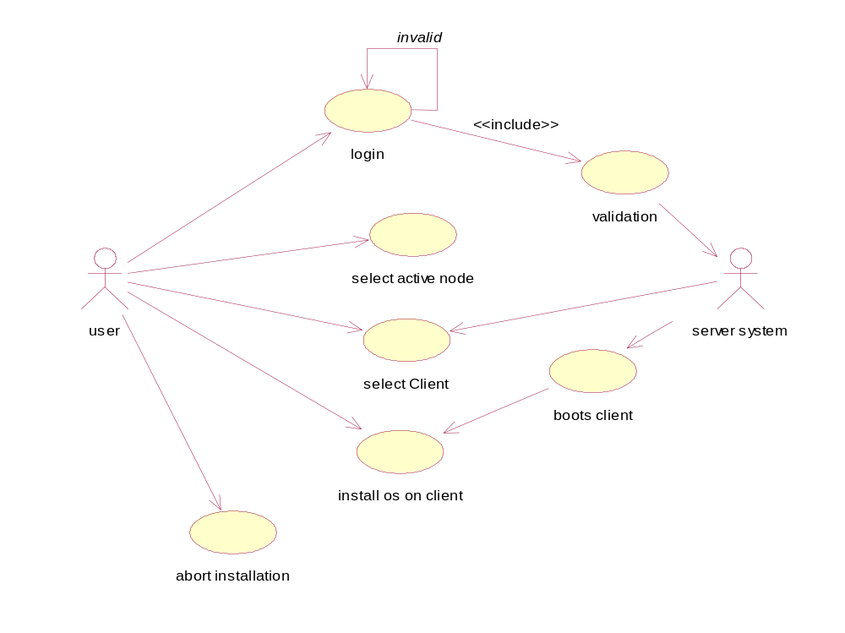

Fig 3.3: Use case diagram for overview of ROS
3.2.2 Functional Modeling
In the functional modeling it describes the function of the propose system. it consist
of two diagram. They are as follows:
- Dataflow diagram
- Control flow diagram

3.2.2.1 Data Flow Diagram:
Data flow diagram (DFD) is also called as ‘Bubble chart’ is a graphical technique, which is used to represent information flow, and transformers those are applied when data moves from input to output.
Control flow diagram (CFD) is representing the control flow of system from one state to another state.

Windows DLLs
Setup Manager

APIs

Remote OS Installation

Services

LAN
Client Configuration

Fig 3.4: Data Flow Diagram Level- 0

APIs
Windows
DLLs
System Initialization

Managing Root Dir
Setup Transfer

Password Validation
Get Client Configuration

Workstation

LAN

Client Selection
Processing
Services

Fig 3.5: Data Flow Diagram Level-1

APIs
System
Initialization
Windows
DLLs

Setup Transfer
System
Initialization
Mang .Setup

Password
Validation

Module &Client Selection
Process

LAN

Services
- Get ClientEstimating
- SchedulingProject initiation
- Requirement gathering

- Tracking
- CoAnalysis
- Design
nf
Client Conf.

Fig 3.6 :Data Flow Diagram Level-2

3.2.2.2 Control Flow Diagram
The large class of application having following characteristics requires control flow modeling
- The application those are driven by events rather than data
- The application those produce control information rather than reports or display.
- The application those process information in specific times.

Client gets Rebooted
Admin Select Client and OS to be Installed
RIS Transfer
Setup Files
Transfer Client Configuration File
Record of Active Clients in N/W
Start OS Installation and Completion

Fig 3.7: Control Flow Diagram for Remote OS Installation

3.3 Risk Identification:
Risk management involves Risk Identification, Risk Analysis and Risk Prioritization;
while Risk protection involves Risk Management Planning, Risk Resolution and Risk
Monitoring
3.3.1 Product Size Risk:
Project risk is directly proportional to product size Risk will be high, when a large deviation occurs between expected values and the previous experience. All the expected information must be compared to previous experience for analysis of risk.
Since we don’t have large deviation between expected & estimated KLOC. So there is no product size risk.
3.3.2 Business Impact Risk:
Microsoft has already implemented this concept only for networking OS like Win 2000 server, Win 2003 Server.
Our project has one difference that it can work any OS. So it is platform independent so we don’t have any business impact risk.
3.3.3 Customer Related Risk:
Customers have different needs. Some know what they want; others know what they don't want.
Since our project is not sponsored so we don’t have any customer risk.

3.3.4 Process Risk:
If the software engineering process is ill-defined or if analysis, design and testing are not conducted in a planned fashion, then risks are high for the product.
As sequential model is best suited for our project. So there is no process risk to our project.
3.3.5 Technical Risk:
Our system requires LAN connection if it is not proper then it may cause disturbance in finding the server destination.
As there was proper LAN connection it does not caused any technical risk to our project.

3.3.6 Development Environment Risk:
If the environment is flawed, it can be the source of significant risk.
Since we have developed our project in project lab so all the resources & tools are available so don’t have any risk.
3.3.7 Staff Size and Expense Risk:
As staff size is fixed for development there is no staff size and expense risk to our project.
3.4 Risk Projection:
Risk Projection involves Risk Management Planning, Risk Resolution and Risk Monitoring.
3.4.1 Preparing Risk Table:
  - ST: Staff related size and experience
- TE: Technology to be built related
- DE: Development Environment

Table 3.3: Risk Table
Risk | Probability | Type | Impact
R1 | 40% | ST | Marginal
R2 | 25% | ST | Marginal
R3 | 20% | ST | Marginal
R4 | 25% | DE | Marginal
R5 | 20% | ST | Marginal
R6 | 20% | TE | Critical
R7 | 25% | ST | Critical

3.4.2 Risk Table Along With RMMM Plan:
This Risk Mitigation Monitoring and Management Plan identify and documents the risks associated with Project. In addition to project risks and technical risks, business risks are also identified, analyzed and documented. Both generic and product-specific risks have been considered. In addition to identification, this document outlines the proactive strategy that we have adopted to avoid these risks. A contingency plan is also prepared for each risk, in case it becomes a reality. Only those risks have been treated whose probability and impact are relatively high, i.e. above a referent level.

Table 3.4: Risk table along with RMMM plan
Risk | Mitigation | Monitoring | Management
R1 | Referred the Software Engineering books | Review with guides | Searching over Internet
R2 | Scheduled studying  Languages from  Standard Books | Coding in programming language | Searching for the language specification for faced problems
R3 | 1) Scheduled studying  concepts from  books  2)Discussion with  Guide | By doing Analysis | 1)Requirement gathering should be done  2)Search the web  for the concept
R4 | Scheduled studying of specification of  Software tools in development phase | Setting up the Software tools during implementation | 1)Breaking down the study in members  2)Checking the alternative for software tools
R5 | Study the related past projects and try to learn as much from their experience | Project guide monitors our project and provide guidance whenever required. | Interact with internal and external guide in case of difficulties and decision making.
R6 | Study N/W related Books | Technical Assistant will help for integrating H/w. | Searching for new H/W If current is not working.
R7 | We’ll discuss about project concepts | Group leader motivate group members while doing work. | Meeting will be conducted after every successful task.

Implementation Details

Chapter 4
Implementation Details

In this chapter basically we have represented the implementation details for every model. And also we have drawn sequence diagram for respective modules and algorithmic steps for each and every module.

4.1 Implementation Steps for Modules
4.1.1 Server and Client Connection
We are going to design a Server Architecture and a Client which will be communicating using TCP/UDP protocol. On the entire client Machine we should have at least Win 98 or Win 2000 Installed. All the Clients are connected to the Server through LAN, Routers etc. When the client is booted it gets connect to the server. The client finds the server on the LAN. The administrator on the Server machine can view the connected client machine and can also view the details of the client. Details such as free memory, free hard disk space, type of OS installed, hardware configuration etc.

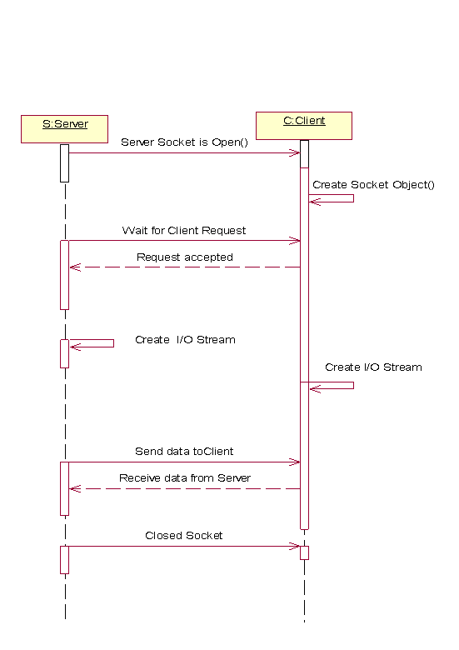
Fig 4.2: Sequence diagram for Server and Client Connection

- Algorithmic steps to Implementing a Server
Step 1. Open the Server Socket:
server Socket server;
DataOutputStream os;
DataInputStream is;
Server = new ServerSocket (PORT);
Step 2. Wait for the Client Request:
Socket client = server.accept ();
Step 3. Create I/O streams for communicating to the client
is = new DataInputStream (client.getInputStream() );
os = new DataOutputStream (client.getOutputStream() );
Step 4. Perform communication with client
Receive from client: String line = is.readLine ();
Send to client: os.writeBytes ("Hello\n");
Step 5. Close sockets
client.close ();
public static int udpport=6001;
final ServerSocket ss=new ServerSocket (udpport);
new Thread () {
public void run(){
try{
while(true){
Socket s=ss.accept();
System.out.println("Connected "+s.getInetAddress());
cm.addClient(s); }
}catch(Exception e){
e.printStackTrace();
}}}
The ServerSocket class is designed to be a”listener”, which waits for clients to connect before doing anything. The Socket class is designed to connect to server socket and initiate protocol. The creation of a Socket object implicitly establishes a connection between the client and server. The accept () method basically stops the flow of the program and waits for an incoming socket connection. When a client connects, our Socket object connection is instantiated.
- Reading from the Socket

/** Instantiate a BufferedInputStream object for reading
/** Instantiate a BufferedInputStream object for reading
* incoming socket streams.
*/

BufferedInputStream bis = new BufferedInputStream(connection.
getInputStream());
/**Instantiate an InputStreamReader with the optional
character encoding. */

InputStreamReader isr = new InputStreamReader(bis, "US-ASCII");
/**Read the socket's InputStream and append to a
StringBuffer */
int c;
while ( (c = isr.read()) != 13)
instr.append( (char) c);

/** Close the socket connection. */
connection.close();
System.out.println(instr);
}
catch (IOException f) {
System.out.println("IOException: " + f);
}
catch (Exception g) {
System.out.println("Exception: " + g);
}
}
}

We start by instantiating a BufferInputStream object bis, calling the getInputStream() method of our Socket object connection. We instantiate an InputStreamReader object isr, passing our BufferedInputStream object bis.
- Algorithmic steps to Implementing a Client
Step 1. Create a Socket Object:
Client= new Socket (Server, port_id);
Step 2. Create I/O streams for communicating with the server.
is = new DataInputStream (client.getInputStream ());
os = new DataOutputStream (client.getOutputStream ());
Step 3. Perform I/O or communication with the server:
Receive data from the server:
String line = is.readLine ();
Send data to the server:
os.writeBytes ("Hello\n");
Step 4. Close the socket when done:
client.close ();

When a client connects, our Socket object connection is instantiated. Once this is done, our program continues through the code MultipleSocketServer: A Server That Handles Multiple Client Connections

public class MultipleSocketServer implements Runnable {
private Socket connection;
private int ID;
public static void main(String[] args) {
int port = 19999;
int count = 0;
try{
ServerSocket socket1 = new ServerSocket(port);
System.out.println("MultipleSocketServer Initialized");
while (true) {
Socket connection = socket1.accept();
Runnable runnable = new MultipleSocketServer(connection, ++count);
Thread thread = new Thread(runnable);
thread.start();
}
}
catch (Exception e) {}
}
MultipleSocketServer(Socket s, int i) {
this.connection = s;
this.ID = i;}

We instantiate a new Thread thread by runnable to the Thread class. We call the start () method of thread and we’re ready go. Invoking the start () method spawns a new thread and invokes the object’s run() method. The actual work within the thread happens within the run () method.
- The run() Method
public void run() {
try {
BufferedInputStream is = new
BufferedInputStream(connection.getInputStream());
InputStreamReader isr = new InputStreamReader(is);
int character;
StringBuffer process = new StringBuffer();
while((character = isr.read()) != 13) {
process.append((char)character);
}
System.out.println(process);
//need to wait 10 seconds to pretend that we're processing something
try {
Thread.sleep(10000);
}
catch (Exception e){}
BufferedOutputStream os = new BufferedOutputStream(connection.getOutputStream());
OutputStreamWriter osw = new OutputStreamWriter(os, "US-ASCII");
osw.write(returnCode);
osw.flush();
}
catch (Exception e) {
System.out.println(e);
}
finally {
try {
connection.close();
}
catch (IOException e){} }}}
The run() method’s responsibility is to run the block of code that we want threaded. In our example the run() method executes the same block of code we built in the SingleSocketServer class. Once again, we read the BufferedInputStream, pretend to process the information, and write a BufferedOutputStream. At the end of the run () method, the thread dies.
4.1.2 Graphical User Interface (GUI)
This module is a user interface system through which the users can interact with the system. Only authorized user can interact with the system. Client software will be installed on every machine on which you want to install fresh OS.
- Implementation Details:-
Design of Graphical user interface with the help of Swing.
Information about user gets stored in the file named Logfile with login time & date. The next piece of information we need to know is the TCP/IP port that the program is going to be communicating on. TCP/IP uses ports because it is assumed that server will be doing more than one network function at a time and ports provide a way to manage this. For example: a server may be serving up web pages (port 80), it may have a FTP (port 21) server, and it may be handling a SMTP mail server (port 25). Ports are assigned by the server. The client needs to know what port to use for a particular service. In the TCP/IP world, each computer with a TCP/IP address has access to 65,535 ports. Keep in mind that ports are not physical devices like a serial, parallel, or USB port. They are an abstraction in the computer’s memory running under the TCP/IP transport layer protocol. Login: After login a valid user can interact with system get avail with the facilities
provided by the software.
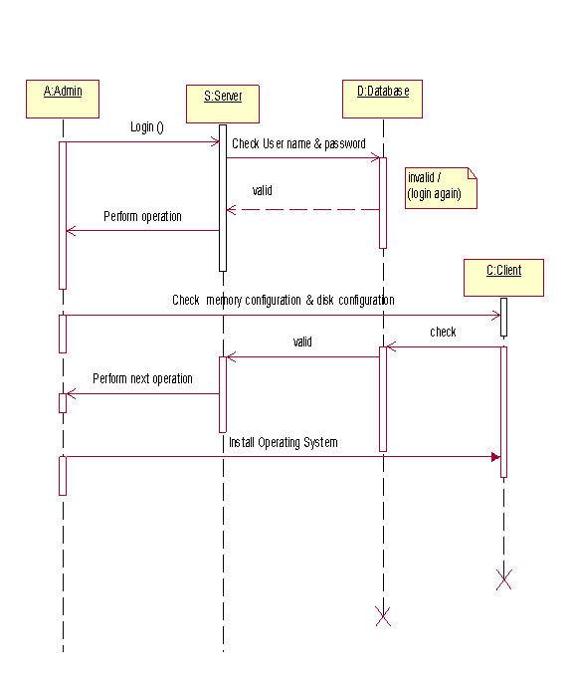
Fig 4.3: Sequence diagram for Graphical User Interface (GUI)
- Implementation of Server side GUI
public class ServerFrame extends JFrame
{
ClientModel model=null;
JTable table=null;
JScrollPane scrtable=null;

public ServerFrame(ClientModel model)
{

this.model=model;
this.table=new JTable(model);
this.scrtable=new JScrollPane(this.table);

table.setRowSelectionAllowed(false);
table.setColumnSelectionAllowed(false);
table.setRowHeight(25);

table.getColumnModel().getColumn(0).setCellRenderer(model.new NameRenderer());

table.getColumnModel().getColumn(1).setCellRenderer(model.new OSRenderer());

table.getColumnModel().getColumn(1).setCellEditor(model.new OSEditor());

table.setBackground(new java.awt.Color(255, 234, 234));

this.setTitle("Remote OS Installation");
Dimension screensize = Toolkit.getDefaultToolkit().getScreenSize();

try
{
javax.swing.UIManager.setLookAndFeel( "javax.swing.plaf.metal.MetalLookAndFeel" );
}
catch ( Exception e )
{
}
try
{
this.setSize(screensize.width,screensize.height);

}
catch (Exception x )
{
System.out.println(“Exception = "+x.toString() );
}
System.out.println("Server Started");
} }

Here we have used Swing, Swing is a set of classes that more powerfull and feasible component that are possible with the AWT. The swing related in a javax.swing and its subpackages such as javax.swing.tree.

4.1.3. Setup Manager
Setup manager consist of two major part first is RIS and second is active directory.
• RIS
RIS consist of following sub-module.
Boot Information Negotiation Layer (BINL):
The BINL service is added during the RIS installation process. The BINL service is responsible for answering client computer network service requests, querying Active Directory on behalf of the client computer, as well ensuring that the correct policy and configuration settings are applied to the client computer during the operating system installation.
Trivial File Transfer Protocol Daemon (TFTPD):
This server side TFTP service is responsible for hosting specific file download requests made by the client computer. The TFTPD service is used to download the Client Installation wizard (CIW) and all client dialog boxes contained within the CIW for a given session.
Single Instance Store (SIS):
Single Instance Store is the service responsible for reducing disk space requirements on the volumes used for storing RIS installation images. When you install RIS as an optional component, you are prompted for a drive and directory where you would like to install RIS. This is the RIS volume. The SIS service attaches itself to the RIS volume, and monitors that volume looking for any duplicate files that are placed on that volume. If any duplicate files are found, SIS creates a link to the duplicates, thus reducing the disk space required.
• Active Directory
This module is come under main module setup manager. Active directory work as client list directory. It will keep the track of number of node attaches to RIS server as well as number of RIS server working in the network. Once the user logs on, RIS checks the Active Directory for a corresponding user account, verifying the password. RIS then checks the RIS specific Group Policy settings to find out which installation options the user should have access to.
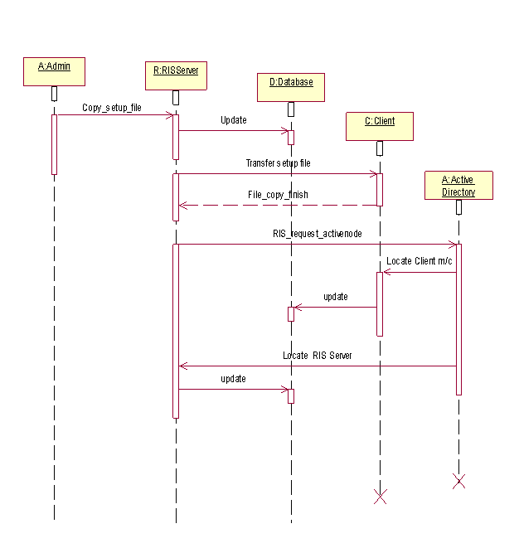
Fig 4.4: Sequence diagram for Setup Manager and RIS

- Getting active node list from network:
/////// NAME DIR COMMAND CONFIG
public class OSConfiguration
{
static Vector v=null;
public static Vector readConfiguration() throws Exception
{
DocumentBuilderFactory factory= DocumentBuilderFactory.newInstance();
DocumentBuilder builder = factory.newDocumentBuilder();
File f=new File("os.xml");
Document doc=builder.parse(f);
Element root=doc.getDocumentElement();
// PARENT NODELIST
NodeList oss=root.getChildNodes();
String name="",dir="",command="",config="";
v=new Vector();
for(int j=0;j<oss.getLength();j++)
{
//FOR GETTING THE RESPECTIVE CLASS
System.out.println(oss.item(j).getClass());

//INDEX FOR VECTOR
int iVector=0;
String nodes[]=null;
if(oss.item(j) instanceof Element)
{
nodes=new String[4];
v.add(nodes);
}

//CHILD NODELIST
NodeList children=oss.item(j).getChildNodes();

for(int i=0;i<children.getLength();i++)
{
Node child=children.item(i);
//For ignoring whitespaces
if(child instanceof Element)
{
Element childElement=(Element)child;
Text textNode=(Text)childElement.getFirstChild();
String text = textNode.getData().trim();
if(childElement.getTagName().equals ("name"))
{
nodes[0]=text;
}
if(childElement.getTagName().equals ("dir")) nodes[1]=text;
System.out.println(nodes[1]);
if(childElement.getTagName().equals ("command")) nodes[2]=text;
if(childElement.getTagName().equals ("config")) nodes[3]=text;
}//end of if
}//end of for
}
return v;
}// end of main

Active directory is used to keep track of active node in the network. In the above code we have used method in that server will send packet to client present in the network and those clients will send reply will be considered as active node in the network.

4.1.4. Transfer Setup
First Administrator selects the client and the OS to be installed on the Client machine. This initiates a Transfer program i.e. the setup is available on the Server Root Directory and the Image of it is transferred to the selected client machine. In this way this module gives us initiation of OS installation. For implementing this module we follow some algorithmic steps given below.
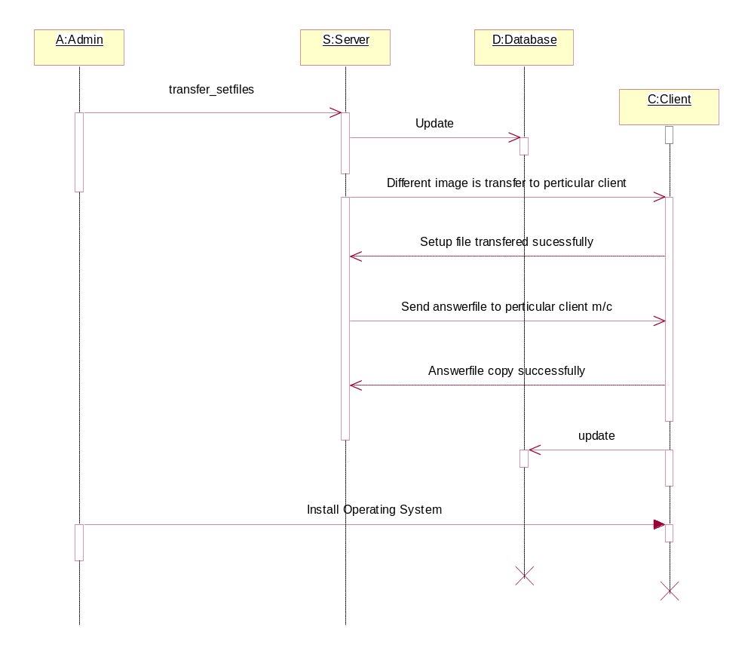
Fig 4.5: Sequence diagram for Transfer Setup
//FILE SERVER TRANSFER CLASS
public class FTServer extends Thread
{ OutputStream os;
ProgressBarCanvas pbc;
ObjectOutputStream oos;
String rootpath;
String answerfile;
String command;
String drive;
{ // its the root file
//GETTING THE DRIVE
System.out.println(drive);
File root = new File(".\\"+rootpath);
File fileanswer = new File(answerfile);
LinkedList ll= new LinkedList();
File filearray[];
filearray=root.listFiles();
for(int j=0;j<filearray.length;j++)
{ System.out.println(filearray[j]);
ll.add(filearray[j]);
}
for(int i=0;i<ll.size();i++)
{ File temp = (File) ll.get(i);
if(temp.isDirectory())
{ filearray=temp.listFiles();
for(int j=0;j<filearray.length;j++)
{ ll.add(filearray[j]);
} } }
//Now you have all the files in hand and they are collected
//in Linked List
System.out.println("Root: "+root);
try
{ // ObjectOutputStream oos=new ObjectOutputStream(os);
System.out.println(drive);
oos.writeObject(drive);
for(int i=0;i<ll.size() && (!abort);i++)
{ File temp=(File)ll.get(i);
System.out.println("Sending: "+temp);
oos.writeObject(
temp.getAbsolutePath().substring (
root.getAbsolutePath().length(),
temp.getAbsolutePath().length() )
); if(temp.isDirectory())
{ oos.writeObject(new String("Directory"));
continue;
}oos.writeObject(new String("File"));
oos.writeObject(new Long(temp.length()));
send(temp,os);
System.out.println("Sent :"+temp);
boolean abort=false;

4.1.5. Setup Monitoring
This module will keep the track of whole installation process. It will give current status of client machine. It will inform about any error which may be come during installation. 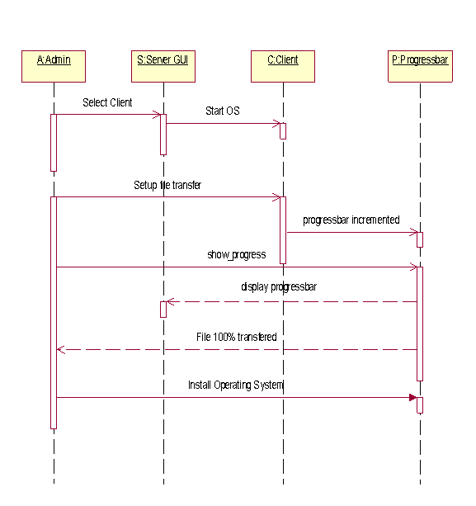
Fig 4.6: Sequence diagram for Setup Monitoring

class ProgressBarCanvas extends JLabel
{
static Color col=new Color(98,162,225);
static Font font=new Font("Verdana",Font.BOLD,12);
static Color col2=new Color(128,128,128);
int val=0;
public void setValue(int val)
{
this.val=val;
repaint();
System.out.println("setValue: "+val);
}
public void paint(Graphics g)
{
String str=String.valueOf(val)+"%";
Dimension d=getSize();
g.setColor(col);
g.fillRect(3,3,(d.width-6)*val/100,d.height-6);
FontMetrics fm=g.getFontMetrics();
int w=fm.stringWidth(str);
int h=fm.getHeight();
g.setColor(Color.black);
g.setXORMode(col2);
g.setFont(font);
g.drawString(str,d.width/2-w/2,d.height/2+h/2-5);
System.out.println("paint" + str);
}
}

In order to keep the track of transfer of OS image to the client side we have used the progress bar. It will show the current status of file transfer in terms of percentage. For that above class is implemented in that we have firstly calculated the size of OS image dynamically. As file transfer proceeds a setValue increments. setValue is a integer variable whose value is calculated by using following formula:

setValue ((i+1)*100/ll.size());

where l1- object of linked list (Dynamic array)
We have a collected all OS image files in a link list and we are sending one file at a time. As a setValue incremented we are filling progress bar with the color by using following method.
g.fillRect (3, 3, (d.width-6)*val/100, d.height-6);

Testing and Results

Chapter 5
Testing and Results

Tests are the individual tests specified in a test plan document. Each test is typically described by
- An initial system state.
- A set of actions to be performed.
- The expected results of the test.
- Testing As a Continuous Process:
All testing follows a pre-planned process, which is agreed to. All tests consider not only a nominal system condition but also address anomalous and recovery aspects of the system. The system is tested in a stressed environment, nominally in excess of 150 percent of its rated capacities. All test products (test cases, data, tools, configuration, and criteria) are documented in a software description document. Every test shall be described in traceable procedures and have pass-fail criteria included.
- Implementation:
Test cases are planned in accordance to the test process and documented with detailed test descriptions. These test cases use cases based on projected operational mission scenarios. The testing process also includes stress / load testing for stability purpose (i.e., at 95% CPU use, system stability is still guaranteed…). The test process thoroughly tests the interfaces and modules. Software testing includes a traceable white box testing, black box testing and other test processes verifying implemented software against design documentation and requirements specified.
- Types of Testing:
- White Box Testing:
A level of white box test coverage is specified that is appropriate for the software being tested. The white box and other testing uses automated tools to instrument the software to measure test coverage.
- Black Box Testing:
A black box test of integration builds includes functional, interface, error recovery, stress and out-of-bounds input testing. All black box software tests are traced to control requirements. In addition to static requirements, a black box of a fully integrated system against scenario sequences of events is designed to model field operation. Performance testing for systems is integrated as an integral part of the black box test process.
  - Unit Testing
Validations were made for each single module and each module was tested independently. Maximum error detection was made at this stage. Proper flow of in bound and out bound information was made.
    - Server and Client Connection
Input : Server.java file
Output : Server programme runs successfully & Server listening on port no. 6564
Input : Client will request to server with server IP address
Output: Communication between client and Server will be started.
    - Graphical User Interface (GUI)
Input : Serverframe.java File
Output : GUI appears on the server screen.
Input : User name and Password in plain text.
Output : Only authorized user will be logged in.
    - Setup Manager
Input: Client and click on Remote OS installation
Output : Remote OS Installation window will appear.
Input: Number of drive for exist on client side.
Output : Desired drive gets selected for installation.
    - Transfer Setup
Input : OS image files to be transferred.
Output : Transfer of files starts & can be seen on command window.

    - Setup Monitoring
Input : Unattend.txt file
Output : Automated installation will start.
Input : Click on start installation
Output : Progress bar will show the status of client machine.

  - Integration Testing
Integration testing was carried out to check whether each module works properly with the integrated module. Different inputs were given to the secondary module from the primary, to check whether it works properly for each input which comes from the higher level. Both Bottom-up and Top-down integration tests were carried out.
Input: User name & login
Output: Valid user gets logged in.
Input: Client will request to server
Output: Request accepted & Client name appear
Input: Select the Client & Click on OS installation
Output: New window appear
Input: Select OS to be install
Output: Number of OS name appear in Server GUI
Input: Select the Partition
Output: Number of drives appears & particular drive selected for installation
Input: Unattend.txt
Output: File will be attach with the OS file as answer file
Input: Click on install
Output: Installation will start.

  - Results
Following results are obtained using test cases:
- Snapshot For Showing copy of complete OS image to the client:

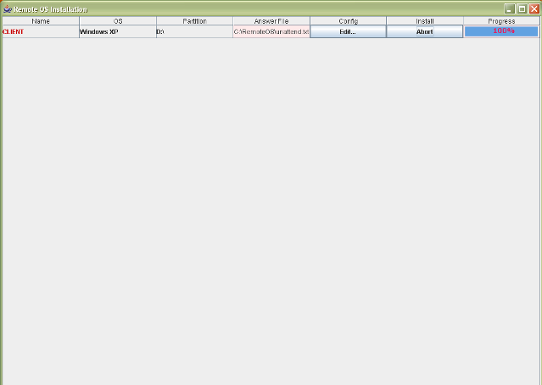
Fig 5.2: Snapshot For Showing copy of complete OS image to the client

- Snapshot For Remote OS Installation showing that the whole image of OS copied to the client:
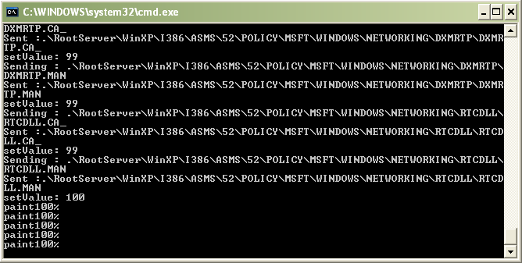
Fig 5.3: Snapshot For Remote OS Installation showing that the whole image of OS
copied to the client

Application and Future Scope

Chapter 6
Application & Future Scope

6.1 Applications
- LAN Based Systems:-
Remote OS Installation is mainly used in companies where it is not possible for n/w administrator to visit each and every client and install different kind of OS on it. So it mainly used in LAN Based Systems.
- Large Organization :-
In the large organization where there are multiple client machines. Where it is not
possible to visit each and every client physically.
It is also useful to small vendors.

6.2 Future Scope
- Linux Installation:-
It will also be possible to install Linux operating system on client side.
- Web Application :-
In future OS can also be installed via internet on a remote client.

6.3 Limitations
- Both server and client eventually should have same configuration for achieving synchronization.
- There should be a proper LAN connection.

Conclusion

Chapter 7
Conclusion

We have designed & implement “Remote OS Installation” which is a key enabling technology that can be leveraged to achieve business benefits. By letting network administrators manage and configure client PCs over the network, RIS can help reduce the cost of ownership and simplify client management. Administrators no longer need to visit clients to install a new operating system or update an existing system.
The client can boot from the network and have the new software installed, regardless of the condition of the local hard drive. Also, booting from the network guarantees that the client boots from a clean, uninfected system, so local media can be checked before startup. Several client management products use these features to reduce the cost and complexity of supporting client PC. Our objective is to provide different choices to user so that he can install desired Operating System without moving physically i.e. remotely. We hope that our project definition will defiantly help to big organization in order to save their time as well as money.

References

References

- Book References:
1. Herbert Schildt,”The Complete reference of Java 2”, Tata McGraw Hill, Fifth Edition,
2002.
2. R. S. Pressman, “Software Engineering”, Tata -McGraw Hill Publications, Enterprise
Edition, 2001.
3. James Rumbaugh, Grady Booch, Ivan Jacobson,”The UML User Guide”, Edition
Wislay publication, 3rd Ed, 2007.

- Web References:

1) “Java network programming”, Sep 2004
http://pont.net/socket/java

2) Michael e. Brown, Manoj Gujarathi, and Gong Wang, “Remote OS Deployment “
www.dell.com/downloads/global/power/ps1q05-20040170-Gujarathi.pdf

3) Microsoft “Remote OS Installation”, May 2007
http://whitepapers.zdnet.co.uk/0,1000000651,260006476p,00.htm

4) “Java Swing “
www.javabeginner.com/java-swing-tutorial.htm

5) Norman Walsh , “A Technical Introduction to XML”, Oct 03, 1998
http://www.xml.com/pub/a/98/10/guide0.html

